2)**Define insecure communication and capture Http website traffic by using WireShark**

**TARGET WEBSITE – demo .testfire.net – login in http request**

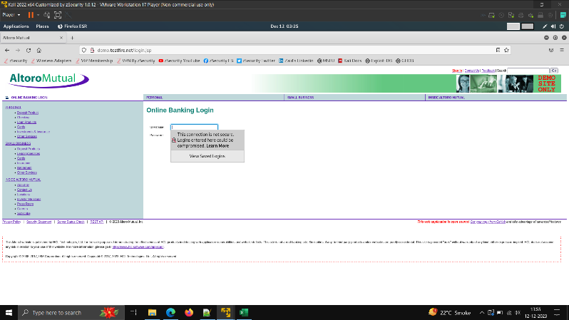

**Using Wireshark – capture the traffic while logging**

**Filter the request using ip.addr == target ip**

**And check do post request for the same.**

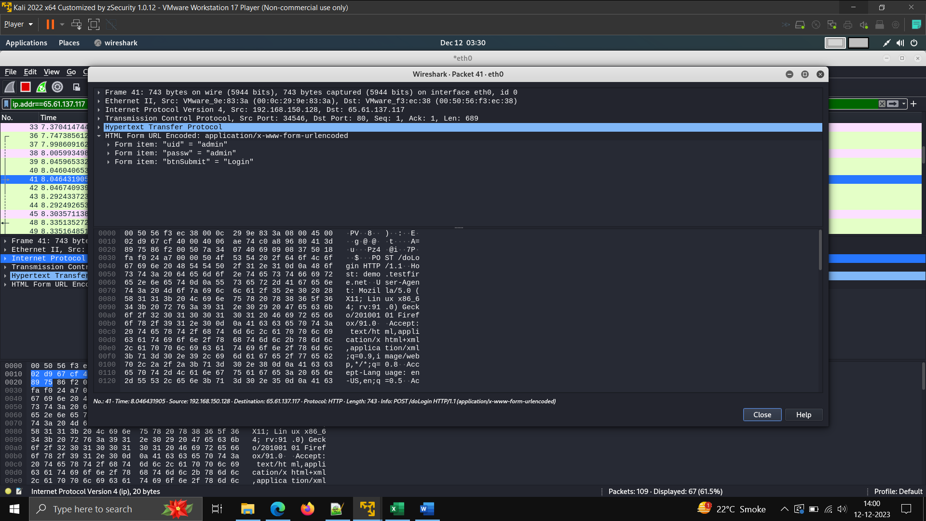

**We are able to get the login and password**